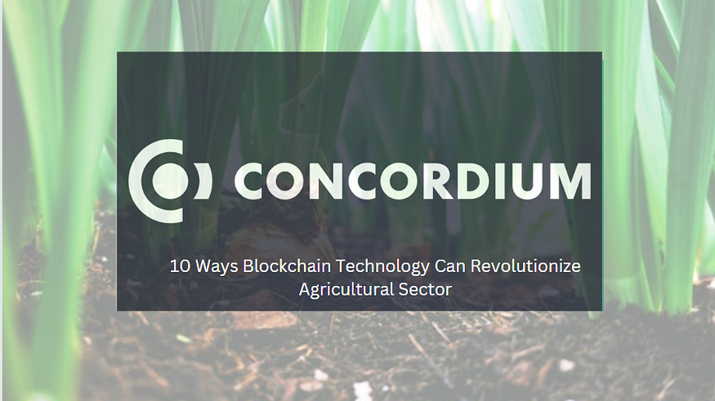

**Concordium — 10 Ways Blockchain Technology Can Revolutionize Agricultural Sector in Developing Countries (Using Nigeria as a Case Study)**

**Abstract:**

*According to the Nigerian Export Promotion Council (NEPC), individuals acting as intermediaries in Nigeria’s agricultural supply chain can take up to 40% of a farmer’s income, significantly reducing their earnings. Additionally, a substantial 64% of the Nigerian adult population, including farmers, faces financial exclusion, lacking access to formal financial services.*

This article explores the transformative potential of blockchain technology in revolutionizing the agricultural sector in developing countries, with a focus on Nigeria. The discussion covers ten key areas where blockchain, particularly leveraging Concordium technology, can address challenges and enhance efficiency, transparency, and trust. The identified areas include eliminating intermediaries, enhancing supply chain traceability, reducing fraud and corruption, promoting financial inclusion for farmers, streamlining payment systems, tokenizing agricultural assets, managing data for precision agriculture, supporting decentralized marketplaces, automating insurance and risk management, and fostering knowledge sharing and collaboration. The article concludes by emphasizing the need for stakeholder collaboration, infrastructure investment, and addressing challenges related to education and technology adoption for successful blockchain implementation in the agricultural sector.

**Elimination of Intermediaries:**

Blockchain technology, integrated with innovative features powered by Concordium, facilitates fair and transparent trade practices, enabling direct sales channels for farmers. This approach reduces the involvement of intermediaries, ensuring transparency and fairness in business connections.

**Supply Chain Traceability:**

Blockchain provides a decentralized and transparent system for recording and tracking various stages of the agricultural supply chain, enhancing traceability. Farmers, distributors, and consumers can trace product origin, processing, and distribution, ensuring food safety and quality.

**Reduced Fraud and Corruption:**

The decentralized and tamper-resistant nature of blockchain reduces fraud and corruption in the agricultural sector. Smart contracts automate agreements and payments, minimizing the risk of fraudulent activities during transactions.

**Financial Inclusion for Farmers:**

Blockchain facilitates secure and transparent financial transactions, offering farmers access to banking services and credit. Decentralized finance (DeFi) platforms, built on blockchain, provide financial services without traditional banking infrastructure.

**Streamlining Payment Systems:**

Blockchain enables efficient and transparent payment systems, eliminating intermediaries and ensuring prompt payments. Smart contracts automate payment processes based on predefined conditions, reducing delays and disputes.

**Tokenization of Agricultural Assets:**

Blockchain allows for the tokenization of agricultural assets, such as land. Farmers can use these tokens as collateral, easing access to funding. This approach provides investors with new avenues to participate in and support agricultural projects.

**Data Management for Precision Agriculture:**

Blockchain secures and streamlines the management of agricultural data, supporting precision agriculture. Farmers can optimize resource use and improve productivity by leveraging data on weather patterns, soil conditions, and crop performance.

**Decentralized Marketplaces:**

Blockchain supports decentralized marketplaces where farmers directly connect with buyers. This leads to improved market access, fairer prices, and reduced reliance on intermediaries.

**Insurance and Risk Management:**

Smart contracts on blockchain automate insurance processes, allowing quicker claim settlements based on predefined criteria. This enhances risk management for farmers, particularly in the face of unpredictable weather conditions.

**Knowledge Sharing and Collaboration:**

Blockchain facilitates secure and transparent sharing of agricultural knowledge, trends, and research. This collaboration among farmers, researchers, and organizations can lead to more sustainable farming practices and improved yields.

In conclusion, the successful implementation of blockchain solutions in the agricultural sector of developing countries requires collaboration, infrastructure investment, and addressing challenges related to education and technology adoption. The partnership between Concordium and Gonana, a Nigerian agricultural marketplace, exemplifies ongoing efforts to address these issues and empower farmers.